Properties of a subspace

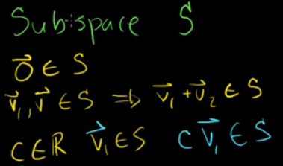

Equation of a line that passes through P1 and P2 in R3

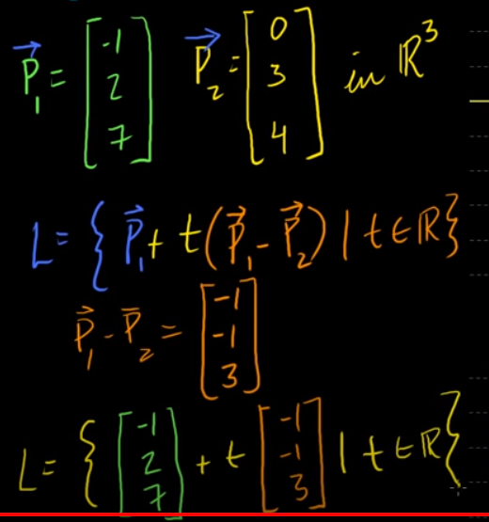

This implies a line in R3 can be represented using the following 3 equations.

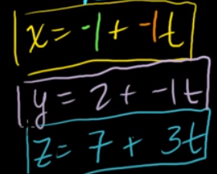

<https://www.youtube.com/watch?v=hWhs2cIj7Cw>

Square of the length of a vector is dot product of the vector with itself

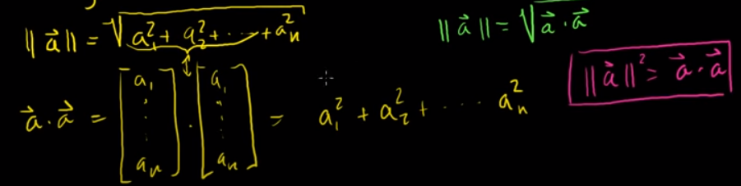

<https://www.youtube.com/watch?v=WNuIhXo39_k>

Cauchy Swarz inequality

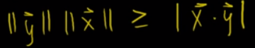

If x = cy, then this turns to an equality.

Watch the entire proof at <https://www.youtube.com/watch?v=r2PogGDl8_U>

Triangle inequality

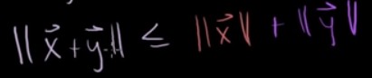

If x = cy, then this turns to an equality.

Watch the entire proof at <https://www.youtube.com/watch?v=PsNidCBr5II>

Angle between two vectors of any dimension.



This implies if two vectors are perpendicular/orthogonal, dot product of the two vectors is 0.

Watch the entire proof at <https://www.youtube.com/watch?v=5AWob_z74Ks>

Given an R3 plane containing the point (x0,y0,z0) and normal to the plane is represented by (n1,n2,n3), equation of the plane is given as:

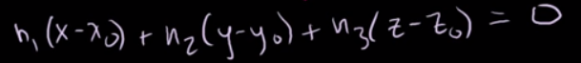

Watch the entire proof at <https://www.youtube.com/watch?v=UJxgcVaNTqY>

Cross-product of two vectors in R3 is defined as

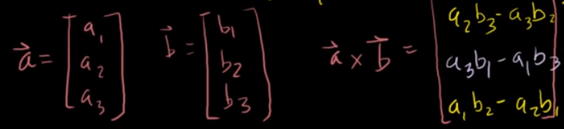

The cross-product is orthogonal to both vectors a and b.

Watch the entire proof at <https://www.youtube.com/watch?v=pJzmiywagfY>

Properties of dot product and cross product

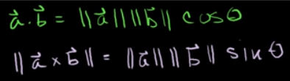

Watch the entire proof at <https://www.youtube.com/watch?v=7MKA2QlKvHc>

In the reduced row echelon form,

* if the number of pivot entries is equal to the number of columns, then there’s a unique solution.
* If there are free (independent) variables, then there are infinite solutions.
* If you get 0 = <a>, then there’s no solution.

Watch the video here <https://www.youtube.com/watch?v=JVDrlTdzxiI>

Matrix multiplication Ax can be interpreted as a linear combination of the column vectors of A, using the weights in x.

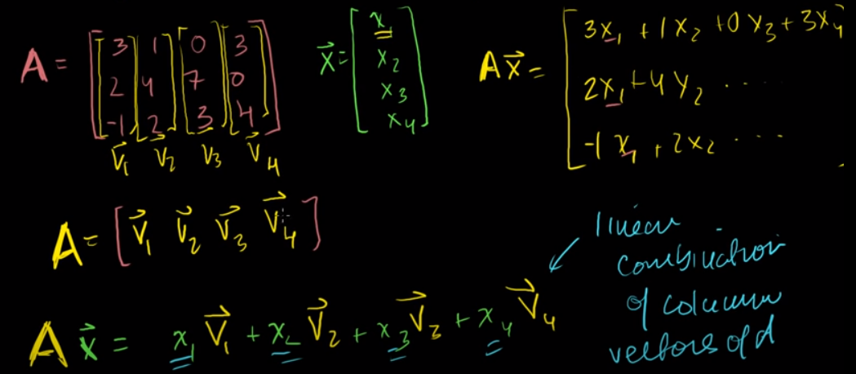

Or as dot product of transpose of the row vectors in A with x.

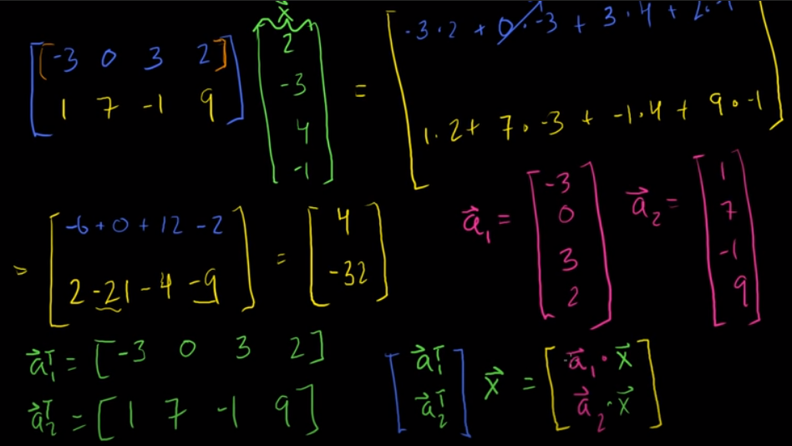

Watch here at <https://www.youtube.com/watch?v=7Mo4S2wyMg4>

Null space is defined as that subspace of the vector space A, such that Ax = 0

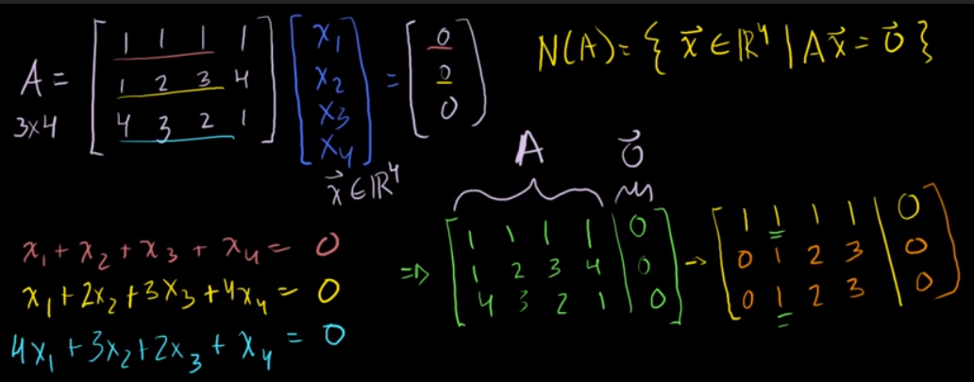

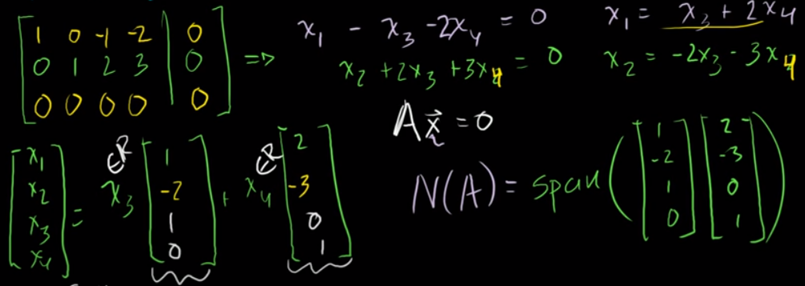

Null space of a vector space A is zero matrix, if and only if A is linearly independent, in which case it has zero free variables in RREF.

Two different ways to find the equation of an R3 plane.

1. Using the normal vector, and two vectors in the plane like this:

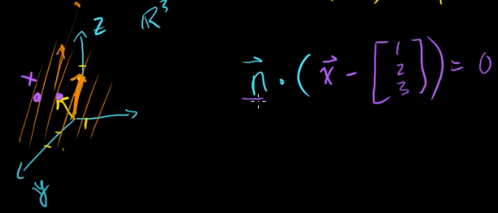 where n is the normal vector. To get n, find the cross product of the given vectors.

1. Using the generic vector [x,y,z] and applying rref.

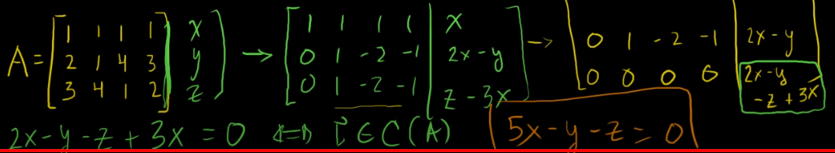

Watch the entire video at <https://www.youtube.com/watch?v=EGNlXtjYABw>

Any arbitrary linear transformation of a vector can be represented as a product of a matrix where each column is the transformation of the basis vectors, and the given vector.

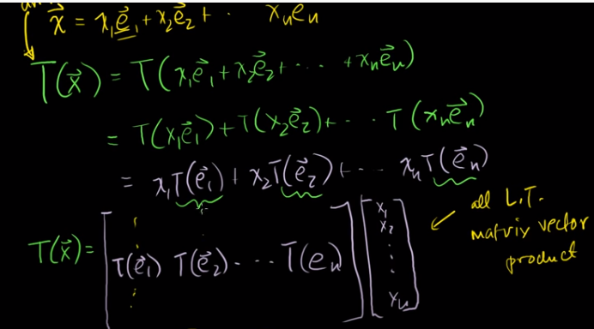

Watch the entire working at <https://www.youtube.com/watch?v=PErhLkQcpZ8>

Linear transformation of a shape is demoed at <https://www.youtube.com/watch?v=MIAmN5kgp3k>

Sum of linear transformation S and T (each represented by matrices A and B). can be represented by A + B.

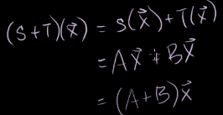

Similarly, scalar multiple of the transformation S (represented by A) can be represented as scalar times A.

Watch the full proof at <https://www.youtube.com/watch?v=wHuY97vss18>

Rotating a vector in R2 is a linear transformation. Assuming the angle of rotation is θ, the transformation matrix is

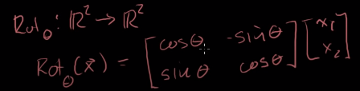

Watch the full proof at <https://www.youtube.com/watch?v=lPWfIq5DzqI>

Projection of a vector x on another vector L can be derived as follows.

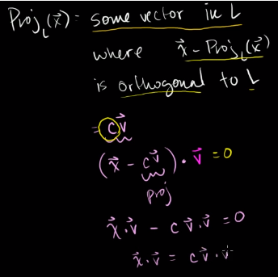

NOTE: L can be represented as a scalar multiple of v.

Hence, projection is 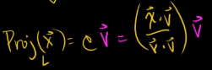

Watch details of the proof at <https://www.youtube.com/watch?v=27vT-NWuw0M>

Projection of a vector x onto another vector v can be rewritten as , given u is the unit vector in the direction of v. It can also be proved that this projection is a linear transformation, represented by the matrix below.

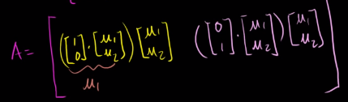 that simplifies to 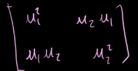

Watch the full proof at <https://www.youtube.com/watch?v=JK-8XNIoAkI>

Composition of two linear transformations can be represented by the matrix obtained by multiplying the individual matrices that represent each transformation. Thus, if B represents the T and A represents S, then the composition of the two transformations is S₀T(x) = AB.

Watch the full proof at <https://www.youtube.com/watch?v=BuqcKpe5ZQs>

If f is invertible, then f(x) = y has a unique solution for x. This implies that there’s only one x-value that produces the specified y-value.

Watch the full explanation at <https://www.youtube.com/watch?v=7GEUgRcnfVE>

A function f is invertible, only if it’s both surjective and injective.

Watch the full explanation at <https://www.youtube.com/watch?v=QIU1daMN8fw>

A linear transformation from Rn to Rm is onto(surjective) only if the column space of the transformation matrix A equals the co-domain. In other words, rref(A) has a pivot entry for every row in A. This means, the given transformation is surjective only if rank of the transformation matrix is m.

Watch the full explanation at <https://www.youtube.com/watch?v=eR8vEdJTvd0>

For Ax = b, the solution set comprises of a particular vector, combined with a null-space.

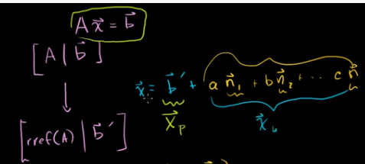

A linear transformation is one-to-one only if the null space is empty. In this case, column vectors of matrix A are linearly independent.

Watch the full explanation at <https://www.youtube.com/watch?v=M3FuL9qKTBs>

For a linear transformation to be invertible, dimensions of the input and output space must be same. This means, the transformation matrix A must be a square matrix. Also implies that the rref(A) is the identity matrix.

Watch more explanation at <https://www.youtube.com/watch?v=Yz2OosyMTmY>